

Department of

Bachelor of Computer Applications

**Ethical Hacking Fundamentals**

Lab File – CA 06

**Subject Code:** 19BCA4C02L

**Class:** IInd Year IInd Semester

**Prepared By:**

Suman Garai

20BCAR0246

**Aim :**

Perform Information Gathering using theHarvester in Kali Linux

**Requirements :**

* Virtualisation Software
* Kali Linux 2022.1
* Basics of theHarvester
* Internet Connection

**Objectives :**

To Run different source scans in a domain and extract information.

**Procedure :**

Basics

Start theHarvester by searching it in the Application section of the taskbar.

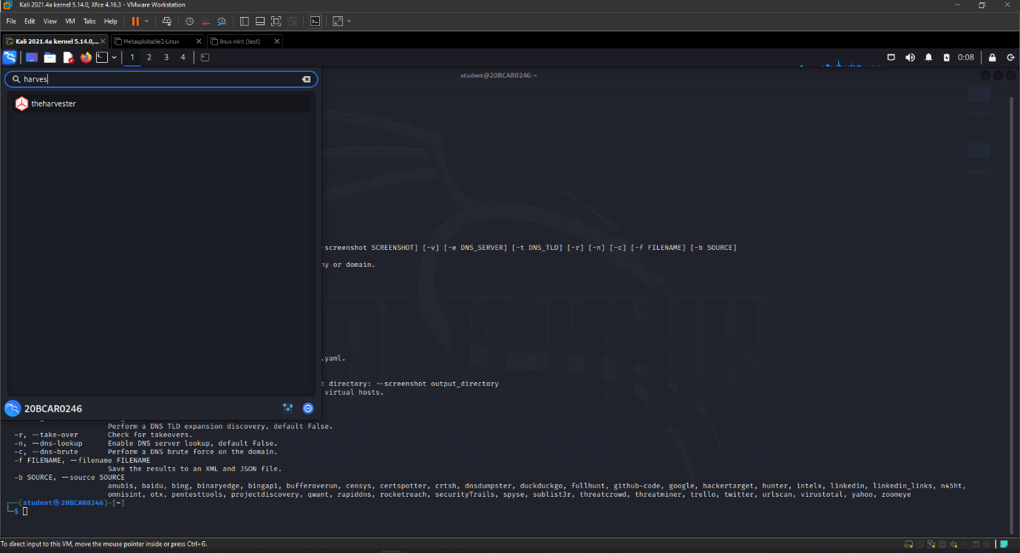

The application window appears in the terminal, along with the commands and the syntax to be used to obtain information.

Using hackertarget as Source for Scan

Command: theHarvester -d jainuniversity.ac.in -s -n -b hackertarget

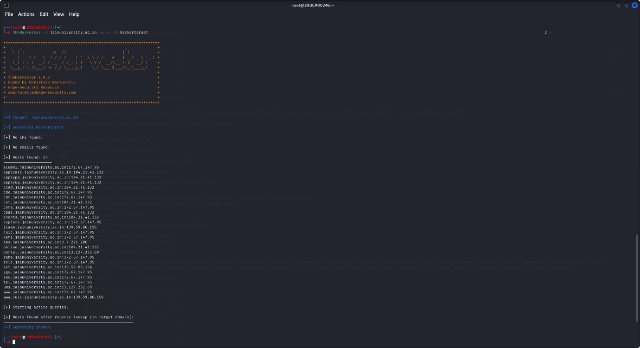

Using linkedin as Source for Scan

Command: theHarvester -d jainuniversity.ac.in -s -n -b linkedin

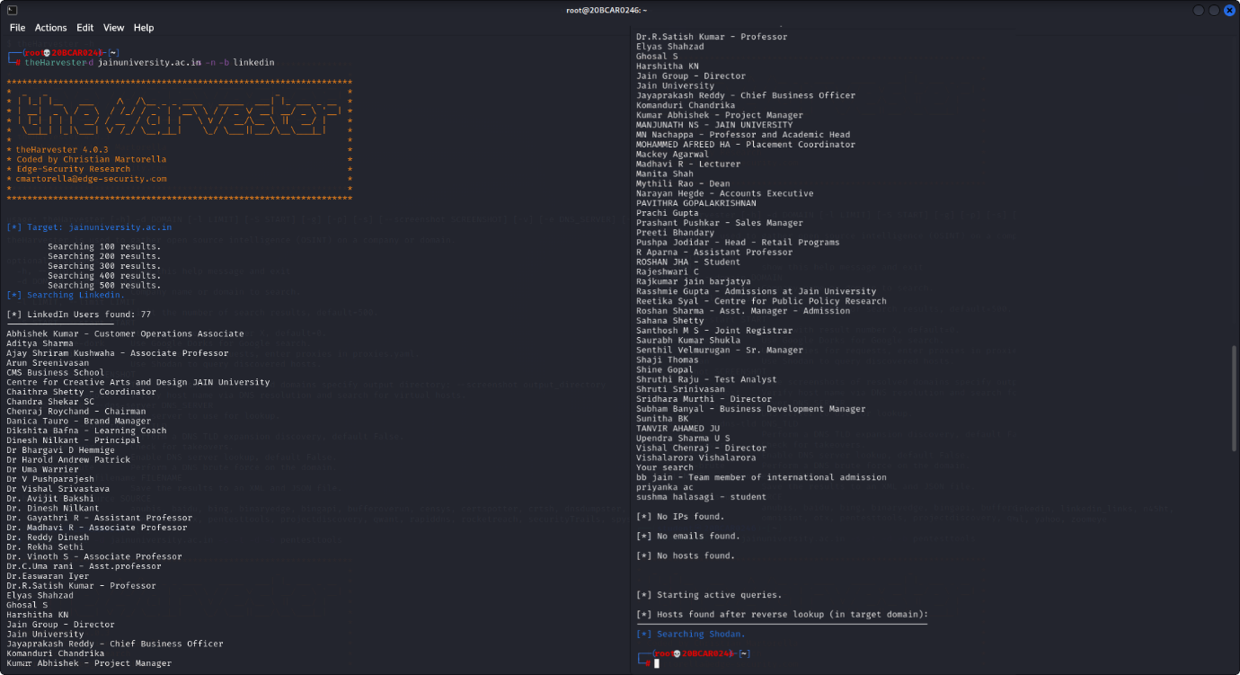

**Conclusion :**

The main purpose of theHarvester tool is to collect publicly accessible email, addresses, subdomains, URLs. This is an excellent tool to use for reconnaissance. theHarvester is a valuable tool for OSINT which allows it to quickly discover a good amount of data like emails, Ip’s, etc. theHarvester is able to acquire names of persons related to the target domain by crawling social networks such as LinkedIn & Twitter, search engines such as Google & qwant and are also able to obtain info using reconnaissance tools like hackertarget and Shodan.